Child Protection Policy

Contents | Page
Introduction, Purpose, Scope | 2
Safe Environment Policy | 3
Staff Code of Conduct | 4
Child Abuse & Neglect Reporting Policy | 6
Appendices
A: Clever Fish Designated Child Protection Officers | 10
B: Reporting of Suspected Child Abuse or Neglect Procedures | 11
C: Child Abuse Incident Form for School Employees & Volunteers | 12
D: Reasonable Suspicion and Information Gathering | 13
E: Dept of Children & Family Services Abuse Reporting Form | 14
F: Removal of Children from School Protocol | 18

Introduction, Purpose & Scope

Clever Fish takes its responsibilities seriously to protect and safeguard the welfare of children and young people in its care. We recognize and acknowledge that our directors and employees have a statutory obligation to report evident or suspected abuse or neglect of a child in our care.

Clever Fish is committed to an effective child protection policy which provides clear direction to our staff and others about expected management and behaviour when dealing with child protection issues. This policy is based on the National Policy, and founded on good practice and sound procedures, ensuring that child protection concerns, referrals and monitoring are handled sensitively, professionally and in ways which support the needs of the child.

There are three main elements to this child protection policy:

- Safe Environment: details what constitutes a safe environment that provides a welcoming, supportive and inclusive learning environment which promotes the well-being of all students and staff and establishes the responsibilities of staff in protecting and perpetuating a safe environment for students.

- Staff Code of Conduct: outlines clear expectations for interactions between adults and children. It explicitly identifies acceptable and appropriate behavior for all adults working with children.

- Child Abuse and Neglect Reporting: defines the steps all adults working with children must take when they report child abuse or neglect.

“Child abuse” or “maltreatment” is defined by the World Health Organization as constituting all forms of physical and/or emotional ill-treatment, sexual abuse, neglect or negligent treatment or commercial or other exploitation, resulting in actual or potential harm to the child’s health, survival, development or dignity in the context of a relationship of responsibility, trust or power.

This includes but is not limited to:

  - Physical or emotional abuse of a child, or neglect of a child, to the extent that the child has suffered or is likely to suffer physical or psychological injury detrimental to their well-being, or where the child’s physical or psychological development is in jeopardy;

  - Sexual abuse including the use of a child in any sexually explicit conduct, rape, statutory rape, molestation, incest or involving a child in looking at or watching sexual activities or encouraging a child to behave in sexually inappropriate ways.

Safe Environment Policy

The Safe Environment Policy helps prevent situations in which children are at an increased risk for abuse because of the physical characteristics of a building. A safe environment is one that increases visibility, ensures adequate supervision and controls access. This policy has been developed based on the National Safe Environment Policy (Policy Ed 24) and has been approved by the Ministry of Education.

Visibility
All staff must be aware of the need for visibility. Where possible, the management team will ensure visibility within the school through the following elements:

- Clear lines of sight throughout the building and in classrooms
- No locked doors, and where possible doors to have windows
- Classroom windows which are unobscured
- Bright lighting in all areas
- Landscaping that ensures open, visible spaces with no possibility of concealment
- Staff only rooms or unused spaces to be locked and accessible by staff only

Supervision
Clever Fish will ensure that the activities of children and staff are adequately supervised by ensuring:

- Adequate classroom and non-classroom (e.g. playground, hallways) supervision.
  - Children are always supervised.
  - There is always a minimum of 2 adults at Clever Fish supervising children.
  - A ratio of no more than 5 children to 1 qualified teacher ensures adequate supervision.
- Periodic walk throughs of the building and grounds to ensure there are no unidentified persons on site
- Clever Fish has security cameras which cover all classroom areas. Other than in bathrooms, all activity is recorded. Parents are informed of these and, if needed, could view the recording.

Access
Clever Fish will ensure that access to children and staff is controlled by implementing the following:

- Restricting access to the school building and outside play/sports areas by fences and controlled gates;
- All visitors, volunteers and contractors must sign the visitors log on arrival and will be escorted around the premises, including to the school office, and where required wear a visitor’s badge identifying themselves;
- Ensuring all staff are aware of restrictions to noncustodial parents’ access to a child or children;
- Requiring that children are only released to authorized parents/guardians, except in the case of an emergency (noting that no child is to be released unattended);
- Requiring that parents notify the school when removing a child from the school other than at typical dismissal times;
- Ensuring that all fences, gates and access points are functioning properly and are in good repair.
Staff Code of Conduct

The Staff Code of Contact outlines clear expectations for interactions between adults and children. It explicitly identifies acceptable and appropriate behavior for all adults working with children. This policy has been developed based on the National Staff Safeguarding Policy (Policy ED 23) and has been approved by the Ministry of Education.

Clever Fish requires that all adults engage in safe, supportive, and respectful interactions with children at all times. The following outlines appropriate and expected conduct for physical behaviour, verbal and digital communication and general conduct.

Physical Behavior

All adults interacting with children must do so in open, public spaces. If one-on-one meetings are necessary for education or emergency purposes, they should be conducted in a public area, in a room where the interaction can be observed, or in a room with the door left open and another adult is notified and can observe the meeting.

Adults may only transport children in accordance with Clever Fish’s transportation policy in our school bus/van.

Appropriate physical behaviour includes contact that maintains physical boundaries at all times and only consists of public and nonsexual touches, such as pats on the upper back or shoulders; help in uneven terrain or child-initiated hugs.

Inappropriate physical behaviour includes contact that abuses, exploits or harasses the child, such as slapping, shaking, pinching, hitting, punching, pushing, grabbing or kicking; patting the buttocks; touching or exposing private body parts; contact which intimates romantic or sexual contact; showing pornography or involving children in pornographic activities.

Communication

All Staff and volunteers should use caution and discretion in all verbal, nonverbal and digital communication with students. All employees will be guided by principles of professionalism and integrity. Communication between adults and children should be transparent about school activities, with the exception of counselling relationships and other topics, such as the child’s well-being, hobbies, interests, out of school activities, etc.

Appropriate verbal communications include providing directions, praise, positive reinforcement with a pedagogical purpose when used consistently and equally for all children. Inappropriate verbal communication includes yelling, threatening, ridiculing, use of expletives, degrading comments, profanity, sexual innuendo and risqué jokes.

Appropriate digital communications include emails and text messages using the school’s email addresses and platforms, while inappropriate digital communication includes private messaging from social media or other private platforms or allowing children access to electronic devices that may expose children to inappropriate content.

General Conduct

Clever Fish recognizes that for children, high self-esteem, confidence, and positive relationships with trusted adults help to prevent abuse. As such, Clever Fish will commit to:

- Provide a positive, supportive, nurturing environment to encourage self-esteem and self-motivation which ensures that children are encouraged to talk and are listened to, where children are respected, valued and cared for; and where children feel safe and secure;
- Ensure that children know that all adults employed by Clever Fish can be approached if they are worried or in difficulty;
- Provide a consistent, encouraging, firm and fair approach to behaviour to ensure each child understands what behaviour is appropriate and what is unacceptable;
- Include in the curriculum, activities and opportunities to equip children with the skills needed to stay safe from abuse and harm;
- Build productive, supportive, positive relationships with our children’s parents and care-givers to provide the required support to our children and their families as needed;
- Ensure our staff are never under the influence of alcohol, tobacco or other drugs in the presence of children.
- Ensuring our staff do not give individual children gifts without the knowledge of parents or guardians, and will ensure no giving of gifts is used in a negative and/or coercive way.
- Comply with all mandatory reporting procedures.
- Cooperate fully with any investigation of misconduct or abuse of children.

To facilitate this policy, Clever Fish will:

- Provide training and development to our staff and supporting them to ensure our teachers are trained to respond appropriately in child protection issues;
- Appoint 4 staff members as ‘Child Protection Officers’ and such appointments shall be made known to all staff, students and parents/caregivers. The Child Protection Officers should always be the primary contact in any incident of suspected abuse or neglect, unless they are directly related to any of the parties involved. Child Protection Officers will ensure that child protection procedures are followed and will make appropriate, timely referrals in accordance with statuary obligations.
- Clever Fish will ensure that ALL of its staff members receive formal child protection training in line with Ministry of Education requirements.

Clever Fish recognizes that while it and its employees have statutory reporting obligations, it is an agent of referral and not investigation. Accordingly, staff members who suspect child abuse or neglect should not raise concerns directly with the requisite parents or care givers, but rather they should report their suspicions to a Clever Fish Child Protection Officer. Proof of neglect or abuse is not required, suspicion alone is sufficient to warrant speaking to a Child Protection Officer. The Child Protection Officer will ensure timely reporting and referral as appropriate and/ or as required to the relevant authority.
Child Abuse and Neglect Reporting Policy

The Child Abuse and Neglect Reporting Policy clearly defines the steps all adults working with children must take when they report child abuse or neglect. This policy has been developed based on the National Child Abuse and Neglect Reporting Policy (Policy ED 22) and has been approved by the Ministry of Education.

Definition of Child Abuse

Child Abuse is an intentional act or series of acts or omission of acts by a parent or caregiver that results in harm, potential for harm, or threat of harm to a child. Child Abuse comes in several forms –

- Physical Abuse: intentional actual or likely physical injury to a child or failure to prevent injury through neglectful actions;

- Sexual Abuse: any sexual act, including non-contact acts, with a child performed by an adult or an older child which include (although not limited to) the following:
  - Sexual touching on any part of the body, clothes or unclothed
  - Penetrative sex, including penetrations of the mouth
  - Encouraging a child to engage in a sexual activity, including masturbation
  - Intentionally engaging in a sexual activity in front of a child
  - Showing children pornography, or using children to create pornography
  - Encouraging a child to engage in prostitution
  - Exposing oneself or saying sexual things;

- Emotional Abuse: actual or likely severe negative impact on a child’s emotional, psychological and behavioral development, resulting from persistent or severe emotional or psychological ill treatment;

- Neglect: severe or persistent failure to provide for a child’s physical, emotional or basic needs.

Legal Requirement to Report

As per the Children Act (2012 Revision), section IIIA.32A, if the Head-Teacher, teachers, counsellor or other employee or volunteer in an institution established for the care and education of children has a reasonable suspicion that a child has been or is being abused or neglected, and the suspicion is formed in the course of the person’s work, that person shall notify the DCFS (Department of Children and Family Services) of the suspicion as soon as practicable after they form the suspicion. Notices shall be in the prescribed manner and format as detailed in the ‘Reporting of Suspected Child Abuse or Neglect Procedures’ attached as Appendix B to this policy.

A person who contravenes this section commits an offence and is liable on summary conviction to a fine of five thousand dollars or to imprisonment for a term of one year or both.

Responsibilities of School Employees and Volunteers

Teachers and other school employees or volunteers who have reason to believe that a student is being abused are mandated to report that information to the school’s Primary Child Protection Officer or an alternative Child Protection Officer for the school.

Clever Fish’s named Child Protection Officers are named in Appendix A.

The following are important points regarding reporting:

- In deciding whether to report an incident or situation of suspected abuse/neglect to the School Child Protection Officer, it is not required that the person making the report have proof that abuse/neglect has occurred. Any uncertainty in deciding to report suspicion shall be resolved in favour of the child and the report made immediately.

- The employee/volunteer will report to the School Child Protection Officer what has been said by the student or what has been observed leading to the suspicion of child abuse/neglect, including the context of that information. There shall be no attempt by the school employee/volunteer to question the child, as the role of investigation lies with Department of Children and Family Services (DCFS) and/or Family Support Unit (FSU) of Royal Cayman Islands Police Service (RCIPS). The child shall be protected from repeated disclosures.

- If the child is injured, the employee/volunteer shall bring the injury to the attention of the lead class teacher or school director immediately, and shall provide any first aid as needed, and adhere to the school’s health and safety policy. Any injury suspected as a result of Child Abuse shall be brought to the attention of the School Child Protection Officer.

- The employee/volunteer referring the suspected case of child abuse/neglect must not contact the parents.

- Given the sensitive nature of child abuse/neglect referrals, the employee/volunteer should not expect feedback following the referral to the School Child Protection Officer. Children Act, (2012 Revision) Part IIIA.32C provides protection to the notifier and requires that the receiver of notification of suspected child abuse (DCFS/FSU) shall not disclose the identity of the notifier to any other person other than in the instance of communicating to another person acting in the course of official duty. Only in cases when “the court is satisfied that the evidence is of critical importance in the proceedings and that failure to admit it would prejudice the proper administration of justice” will a notifier be called to provide evidence. In these instances, Clever Fish Management may support the employee by assigning another professional to accompany them at such hearing.

- School leadership shall undertake to ensure that all employees/volunteers are provided with information and training that will enable them to carry out their duty to report suspected child abuse or neglect as well as training regarding identifying and responding appropriately to Child Protection issues, in line with Ministry of Education requirements.

Responsibilities of the Child Protection Officer

Clever Fish is mandated to appoint additional Child Protection Officers to assist when the primary officer is unavailable.

If the School Child Protection Officers have reasonable suspicion that a child may be suffering or may have suffered abuse/neglect, there is immediate duty to report that suspicion and the information upon which it is based to the Department of Children and Family Services (DCFS). This requirement applies whether or not the information was initially extended in confidence. This requirement also applies whether the information comes directly from the child or indirectly from another employee, volunteer or community member.

It is the School Child Protection Officer’s (CPO) duty to report incidents or suspicions of child abuse/neglect; it is not the CPO’s responsibility to investigate. In speaking with the child, the CPO will take careful note of what is said and the context in which it is said. Care will be taken not to ask leading or unnecessary questions. Documentation of what is said (or of any injuries) is important. The student’s own words shall be used as much as possible.

Once information for a report has been obtained, the School Child Protection Officer will make a referral to MASH in accordance with their protocols and a telephone referral to the relevant DCFS contact person (district supervisor or intake worker) if appropriate. If after hours, contact shall be made directly with the RCIPS. The telephone referral will be followed by a written referral within 24 hours, utilizing the DCFS Referral Information for Child Abuse Form (see Appendix C).

Immediately prior to or soon after making a report of suspected abuse/neglect, the School Child Protection Officer shall inform the Head-Teacher or Director of that action. These individuals will be informed of the report but not the specific details of the report.

It is not the School Child Protection Officer’s responsibility to inform parents of any report of suspected child abuse/neglect; however, when making the referral to DCFS, how the parents become informed will be discussed and the best course of action agreed upon with that agency.

A record of follow-up contact made to external agencies regarding a referral shall be kept.

Responsibility of the School after referring a case of Suspected Child Abuse and Neglect

Following any report of suspected child abuse/neglect, the School Child Protection Officer will assume a role of student support and advocacy as required and along with school Management will cooperate with DCFS and/or FSU and the MASH Child Protection Officer throughout any investigation. Management will release relevant student records and employee/volunteer reports as required to the DCFS and/or FSU and MASH.

If the suspected offender is an employee of Clever Fish, or a volunteer, employees/volunteers should report their concerns to a School Child Protection Officer. Concerns or reports should not be brought to the attention of the suspected employee/volunteer. If the suspected offender is a Child Protection Officer, the employee/volunteer should report their concerns to the school’s Director or Head-Teacher.

The suspected employee/volunteer will be reassigned to other duties while the investigation is conducted. If the concern/report provided by the employee/volunteer indicates that there is reasonable suspicion that a child was abused, the CPO shall complete the requisite form and follow up with a phone call to the MASH unit to take further instructions. Otherwise, the Director or Head-Teacher will carry out an initial review and, if necessary, an internal investigation to establish whether there are grounds for a MASH referral. If a referral is made to the MASH, the suspected staff member, with approval from the MASH unit, will then be reassigned to a non-contact role until the investigation has concluded. An internal investigation may also be necessary to determine whether Clever Fish policies were violated (independently of whether or not the threshold for a MASH referral was met). Violations of Clever Fish policies shall be handled accordingly by Clever Fish management.

Prior to interviewing a child at school, DCFS will contact school administration. It is not the school’s responsibility to inform parents of the interview; however, the subject of parent notification will be discussed with DCFS and a decision taken in the best interest of the child.

School leaders shall assist DCFS by providing an appropriate interview space and arranging discreetly for the student to be interviewed. The DCFS worker may request that a school employee be present during an interview to offer support to the student. If the worker does not ask for student support, the School Child Protection Officer may make this request on behalf of the student.

If it is necessary for DCFS staff to remove the child from school during the investigation, the school shall comply with this request and cooperate fully with said agencies throughout the investigative process, in accordance with Clever Fish removal of children from the school protocol (Appendix F).

Following investigation, the school’s Senior Leadership Team and/or the School Child Protection Officer, as appropriate, will participate in DCFS case conferences and liaise with DCFS staff on behalf of the child as requested.

All information related to suspected child abuse/neglect cases shall be treated confidentially. Clever Fish will provide a secure cabinet for the filing and maintaining of confidential information related to child abuse/neglect cases. No documentation related to child abuse/neglect reports or investigations shall appear within the student’s cumulative folder.

On a regular basis, and no less frequently than on an annual basis, the Ministry of Education may request that the School Child Protection Officer submit the total number of child abuse and neglect referrals made to DCFS by the respective school.

When following procedures for reporting suspected cases of child abuse/neglect, the safety and welfare of the student will always dictate which course of action is to be pursued. Any uncertainty shall always be resolved in favour of the child’s best interest. When in doubt, consult with the Department of Children and Family Services and/or the MASH Unit.

Appendix A: Clever Fish Designated Child Protection Officers

Staff Member | Position
Melanie Wright | Primary CPO (Pastoral Lead and SENCo)
Stephanie Rasmussen | Head-Teacher
Alexander Frazer | PE Teacher
Nicola Sowerby | Director

Effective Date: February 2023 – final and approved by Camilla Ferrira Feb 2023

Appendix B: Reporting of Suspected Child Abuse or Neglect Procedures

All employees and volunteers are required to report any disclosure or suspicion of child abuse, even in historic cases. It is not the educator’s role to investigate or determine the validity of what is observed or told. A report template is available and must be used when reporting suspected abuse (Appendix C). The template also provides a ‘check and record’ section for use by the Child Protection Officers.

In cases where an employee/volunteer observes concerning behaviour which may indicate abuse/neglect:

- Thank the student for sharing the information;
- Refrain from asking leading questions (eg: did mommy do that?), and focus only on open ended questions such as “tell me more…?, how did that happen
- Complete a report form (Appendix C) as soon as possible (ideally immediately) and submit to the school’s CPO. If the CPO is not present, then email the form to the CPO with the report attached;
- Refrain from discussing the matter with anyone else, or further with the child.

The designated Child Protection Officer will (ideally within the hour):

- Inform the Head-Teacher (if the CPO is an alternate) that there is a child protection issue which will be referred to DCFS. No details should be provided beyond this. If the alleged perpetrator is employed on the school compound, the Head-Teacher and Director must be informed.
- Call DCFS to report the alleged abuse and follow up the call by emailing the report to the relevant officer at MASH@gov.ky.

Follow up procedures (ideally within 24 hours):

  - Follow up the phone call by attaching the DCFS report form to an email to DCFS at MASH@gov.ky if it has not already been sent;
  - File the email and report in a confidential child protection file which is held by the director;
  - Log any subsequent agency actions on the report held on file.
  - If further to the report to DCFS there are ongoing reports of concern or it appears there has been no effective follow-up, the Child Protection Officer should initiate calls to DCFS and log these on the report form for this purpose and it should be held on file. NB: If a student is removed from school by DCFS and the parent asks regarding where the child is, they should be directed to call DCFS for information. Any contact with parents should be a decision for the Child Protection Officer who should seek advice from relevant DCFS/MASH staff before doing so.

Appendix C: Child Abuse Incident Form for School Employees/Volunteers

Please attach to Abuse Reporting Form (Appendix D) and keep in child’s private Child Protection File.

State the nature and extent of the current injury, neglect, or sexual abuse to the child in question and circumstances leading to the suspicion that the child is a victim of abuse or neglect:
_________________________________________________________________________________________
_________________________________________________________________________________________
_________________________________________________________________________________________
_________________________________________________________________________________________
_________________________________________________________________________________________
_________________________________________________________________________________________
_________________________________________________________________________________________
_________________________________________________________________________________________
_________________________________________________________________________________________
_________________________________________________________________________________________

Information concerning previous injury, sexual abuse or neglect experienced by this child or other children in this family situation, including previous action taken, if any:
_________________________________________________________________________________________
_________________________________________________________________________________________
_________________________________________________________________________________________
_________________________________________________________________________________________
_________________________________________________________________________________________
_________________________________________________________________________________________
_________________________________________________________________________________________
_________________________________________________________________________________________
_________________________________________________________________________________________
_________________________________________________________________________________________

State other known information that may be helpful in establishing the cause of the child' status:
_________________________________________________________________________________________
_________________________________________________________________________________________
_________________________________________________________________________________________
_________________________________________________________________________________________
_________________________________________________________________________________________
_________________________________________________________________________________________

Date: …………………. Signature of Employee/Volunteer: ____________________________________

Appendix D: Reasonable Suspicion and Information Gathering

Reasonable Suspicion

- Reasonable suspicion is a legal standard of proof that is lower than reasonable belief
- Reasonable suspicion is more than a ‘hunch’. However, if you have a hunch, do not dismiss it. Gather information available to you and determine whether the hunch can be substantiated
- Reasonable suspicion must be based on ‘specific and articulable facts’ (for example, observations of indicators of abuse or neglect, or potentially harmful actions)
- It is reasonable for professionals to make ‘rational inference’ from facts (for example, apply your knowledge of the impact of harmful behaviours, or Adverse Childhood Experiences, on children, OR to describe your reasons for feeling worried about a child)

Responding to Disclosures – Information Gathering versus Investigating/Interviewing
- Employees and volunteers of Educational Institutions should not seek to interview children when disclosures are made. Great caution is needed on how to question a child and when to stop.
- Children often ‘test the water’ or make partial or unclear disclosures, particularly about child sexual abuse. The person in a position of responsibility receiving the disclosure may need to ask questions to clarify whether the child has indeed just disclosed something to them.
- How a person in a position of responsibility responds when a child discloses abuse is important to the child’s recovery, safety, and the criminal case.
- It may be necessary for the person in a position of responsibility to gather additional information to:
  - Ascertain a child’s need for medical attention
  - Alert the authorities of potential imminent danger, or
  - Make other initial decisions.
- To this end, open ended questions such as “tell me more”, “explain to me” or “describe” should be asked.

DO | DON’T
Stay calm | Panic or look shocked
Listen and be attentive | Rush the child
Start with open ended questions:  ^ tell me more  ^ I notice you have a bruise, how did that happen? | Ask leading questions:  ^ Did mommy do this to you?  ^ Were you at your dad’s house  ^ Did you get hit with a belt?
Follow up with closed questions if needed:  ^ Who did this?  ^ When did this happen?  ^ Where did this happen?  ^ How often does this happen, or  ^ Has this happened before? | Minimise, make assumptions, or offer explanations
 | Imply the child is lying
 | Criticise the alleged perpetrator
 | Press the child
 | Try to deal with it yourself
Make appropriate plans to ensure the child feels safe & supported following a disclosure, for example “Would you like to go outside with your friends, or would you prefer to stay here?” | Scare the child, or make promises that “things will be fine”

Appendix E: DCFS Suspected Child Abuse Reporting Form
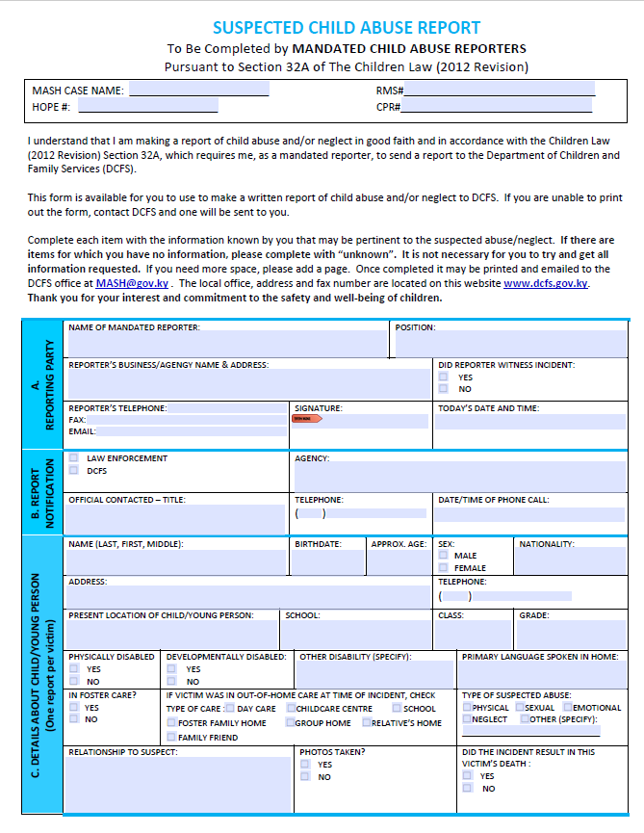
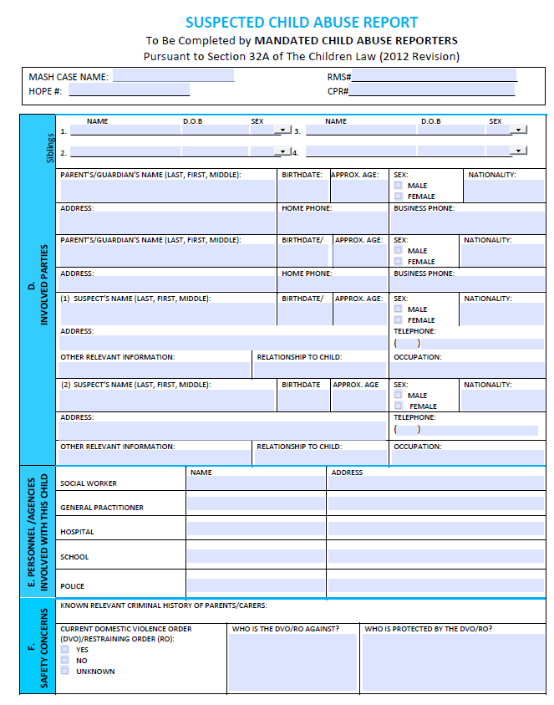
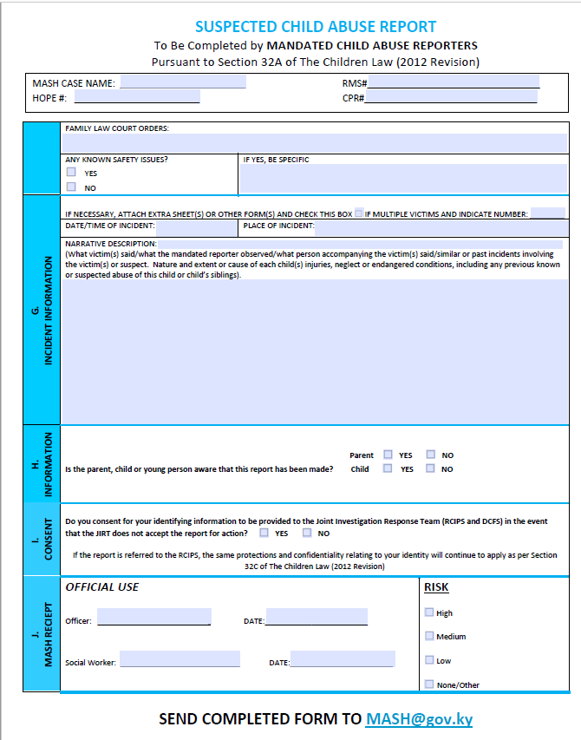

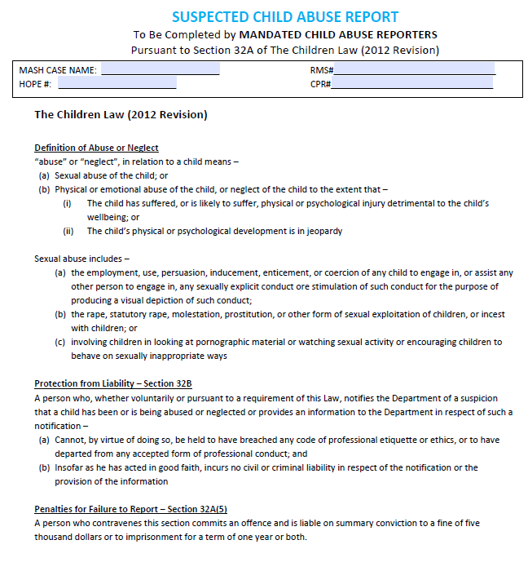

Appendix F: Removal of Child from School Protocol

RCIPS/DCFS Contact with Students at School
Outline

In certain circumstances it may be necessary for a member of the RCIPS and/or DCFS to meet and have a confidential discussion with a child without the consent or knowledge of the parents/guardian. In some cases it may also be necessary for the child to be removed from school by DCFS/RCIPS Officers without the consent or knowledge of the parents/guardians. If either of these actions are taken, the circumstances requiring the meeting and /or removal will have been carefully considered by the relevant agencies and appropriately authorized.

However, Clever Fish has a duty of care to all of our students, and it is essential that when a member of the RCIPS or DCFS arrives at school to meet a child that the protocol below is followed.

School Protocol
If a member of the RCIPS/DCFS visits the school and requests to see a child the following protocol must be followed:

- School Administration immediately informs Child Protection Officer (CPO) that DCFS/RCIPS are on campus and wish to speak with a child.
- CPO meets the Officers and confirms their identity by requesting to see their DCFS/RCIPS issued ID Cards.
- CPO ascertains the purpose of the visit and facilitates the initial meeting in an appropriate space. The CPO should support the child during the meeting with the agreement of the attending Officers.
- If the Officers subsequently need to remove a child from school the CPO must ensure that the proforma below is completed and stored appropriately.
- The DCFS/RCIPS Officers are expected to inform the parent/guardian that the child has been removed from school before the end of the school day

DCFS/RCIPS Removal of a Child from Clever Fish School

RCIPS/DCFS Officer Details
Name: |  |  | ID Number:
Name: |  |  | ID Number:
Student Details
Name: |  |  | School:
Parental Consent
Is the parent/guardian aware that the child is being removed from school? YES NO
If No, what is the justification for removal without consent?

Who will inform the parent/guardian that their child had been removed from school?

When will the parent/guardian be informed that their child has been removed from school?
Signatures
Name: |  | Signed: |  | Date: |  | Time:
Name: |  | Signed: |  | Date: |  | Time:
Name: |  | Signed: |  | Date: |  | Time:

When completed this form will be retained by the School Child Protection Officer

