Marking Policy

CF School recognises that feedback can be given to students in a number of ways, and should be, in order to be as effective as possible.

Teachers at CF School use a combination of both verbal and written feedback to ensure pupils make as much progress as possible.

CF School also recognises that the research suggests that feedback can be most effective at moving students forward in their learning when done ‘in the moment’. This can be done verbally or through Live marking and feedback – where a teacher marks, and gives feedback on, a student’s work as they are working on it. This has benefits that include:

- Addressing misconceptions before they become embedded
- Offering instant recommendations about how to improve a piece of work as it is being completed – ending up in a higher standard of work being produced at the end.
- Getting students into the habit of engaging in a constant feedback loop that is low-threat and high impact.
As a result, CF School does not dictate that teachers make particular comments at particular times on particular pieces of work in students’ books. Instead, it should be clear from both the teacher’s written annotations and, crucially, the quality of a student’s improvement of their work that the student has received, and is in the habit of regularly acting upon, high quality feedback.

A student’s exercise book is one piece of evidence as to whether they are making good progress in their subjects, and is one indicator of the quality of teaching over time. The quality and impact of a teacher’s marking and feedback is an integral part of CF School’s formal lesson observation process, which aims to analyse and evaluate the quality of teaching and learning in a particular subject, and in the lessons of a particular member of staff, over time.
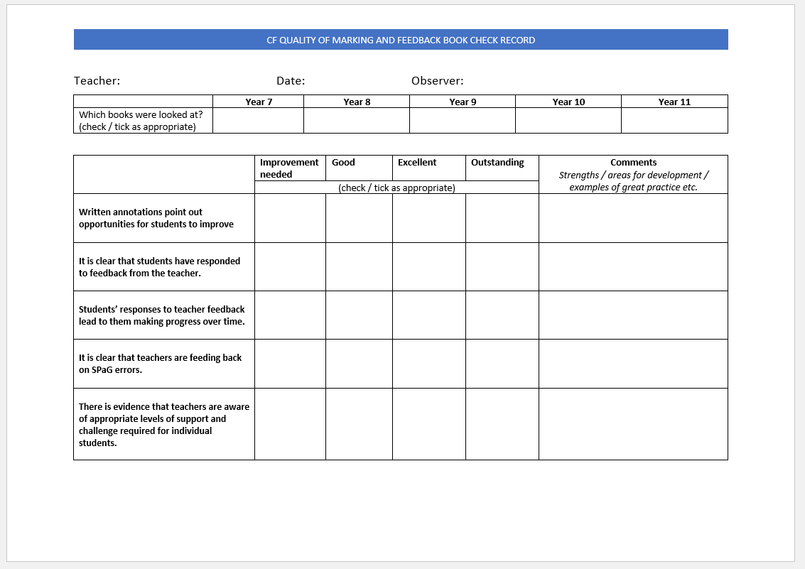
A record of the quality of an individual teacher’s marking and feedback can be found on the following proforma, completed as part of the lesson observation process (one each half term):

