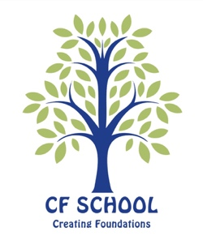

Curriculum, Assessing and Reporting Policy

Curriculum

All students in Year 7, 8 and 9 follow a balanced curriculum which sets the foundations for IGCSEs (International General Certificate of Education) at the end of Year 11.

Subjects studied by all students are: English Literature and Language, Maths, Science, RE, History, Geography, Latin, Art, Music and Drama (Art, Music and Drama re taught on a carousel) PSE (Personal, Social Education) and PE.

The Curriculum Overview provides you with details as to what is studied in each subject each term.

Assessing

Teachers use a range of formative and summative assessments to ensure that each child is making progress such as: classwork, homework, topic tests, extended pieces of writing and formal school examinations.

School Examinations

All students sit formal school examinations twice yearly. The first set of school exams happens at the end of Term 1 and tests students on the work studied in the first term. At the end of the school year, all students sit end of year exams which test everything taught that school year.

Reporting

There are 4 school reports sent home to parents each school year.
The dates for these are on the school calendar.
1. First Term Report, Interim Report 1 - provides a classwork assessment grade and effort grade
2. Christmas Report, Written Report 1 - after the Christmas exams, provides a classwork grade, the exam grade and a written comment from each teacher.
3. Easter Term Report, Interim Report 2 - provides a classwork assessment grade and effort grade provides a classwork grade, the exam grade and a written comment from each teacher.
4. Summer Report, Written Report 2 - after the summer exams, provides a classwork grade, the exam grade and a written comment from each teacher.

