Additional Learning Support
Needs Policy

Contents | Page
1. Aims & Objectives | 3
2. Legislation & Guidance | 4
3. Definitions | 5
4 a) Roles & Responsibilities - CF School | 6
4 b) Roles & Responsibilities - SENCO | 7
4 c) Roles & Responsibilities - Class Teacher | 8
4 d) Roles & Responsibilities - School Based Support Team | 8
4 e) Roles & Responsibilities - Multi - Disciplinary Support Teams | 9
4 f) Roles & Responsibilities - Parents | 10
4 g) Involving the Child | 11
5. Identification & Assessment | 12
6. The three phases of action | 12
7. Arrangements for ALSN / SEND Training | 15
8. Complaints Procedures | 17

Approved and adopted:
This policy has been developed and implemented in consultation with Department of Education Services (DES), the Special Educational Needs Coordinator (SENCO) and CF School. This policy is required as set out in the Ministry of Education’s Code of Practice: Identification, Assessment and Provision for Additional Learning Support Needs in Education (2021). Link to the ‘Code of Practice’.

Review Date: September 2024

SIGNATURES:
Head-Teacher:
Special Educational Needs Coordinator:

- Aims & Objectives
Vision
CF School is a truly inclusive school and as such is committed to identifying, assessing, and providing for all additional learning support needs, including those with special educational needs and disabilities.
We firmly believe that all students with additional learning support needs (ALSN), including special educational needs and disabilities (SEND) are entitled to an education which enables them to:
- achieve the best possible outcomes
- make a successful transition through each stage of their lives
- become confident individuals living fulfilling lives

Objectives of the ALSN Policy

The specific objectives of the CF School ALSN Policy align with the Cayman Islands’ Code of Practice for Additional Learning Support Needs in Education (the ‘Code of Practice’) and are as follows:

- to identify all children with additional learning support needs, including SEND, and to ensure that their needs are met;
- to ensure that all children with additional learning support needs, including SEND, have access to a balanced curriculum and are included in the activities of CF School;
- to ensure that all children with additional learning support needs, including SEND, make the best possible progress, as defined by the Office of Education Standards (OES) criteria;
- to ensure that parents/guardians are informed of their child’s individual needs, the provision offered, and that there is effective communication between parents/guardians and CF School.
- to ensure that children are supported in expressing their views and are fully involved in decisions which affect their education, to the fullest extent possible; and to promote effective partnerships

- Legislation and Guidance

This policy is aligned to the Code of Practice issued by the Cayman Islands’ Ministry of Education as required by the Education Act, 2016, Section 33(1), which became operative in August 2021. The Code of Practice contains excerpts from both primary legislation and regulations pertaining to SEND.
In accordance with the Code of Practice the following legislation, agreements, policy, and guidance were also considered when developing the Code of Practice that requires schools to produce this policy:
United Nations Convention on the Rights of the Child, 1989;
United Nations Convention on the Rights of the Child Persons with Disabilities, 2007;
Children Act (2012 Revision);
Cayman Islands’ Disabilities Policy, 2014 – 2033;
Education Act, 2016;
Education Regulations, 2017;
Disabilities (Solomon Webster) Act, 2016;
Successful Schools & Achieving Students 2, Office of Education Standards (OES), October 2020.

- Definitions
Within the Cayman Islands, the Code of Practice applies to all children with additional learning support needs, including SEND. Children’s additional learning support needs, including SEND fall within the following 4 broad areas of need and support:
- communication and interaction
- cognition and learning
- social, emotional and mental health
- sensory and/or physical needs
The term “additional learning support needs” is an umbrella term that describes the continuum of needs that requires additional learning support, including those children with exceptional and substantial needs associated with SEND categorization.
A child is understood to have additional learning support needs if they require support that is additional to or otherwise different from the educational provision generally made for children of the same age in schools. A child can have additional learning support needs without the need for formal assessment procedures that could lead to special educational needs and/or disability categorization and the requirement for a statement of eligibility. A child who has special educational needs and/or has a disability (SEND) will, by definition, have 'additional learning support needs' (ALSN).
As per the Education Act, 2016: Special educational needs – in relation to a student (a child), means that, by reason of characteristics of body or mind personal to the student, the student’s educational needs cannot be satisfied otherwise than by making exceptional provision in relation to the student; and, for the purposes of this definition:
A) Provision is exceptional in relation to a student (a child) if it is substantially different from that which is made for the education of the generality of persons of equivalent age and description; and
B) Students (children) for whom English is an additional language or who are gifted or talented are not to be treated as having special educational needs*

*Children with English as an additional language or who are gifted or talented may have additional learning support needs.
If a child is determined to have special educational needs and/or disabilities, they must be set out by the responsible authority in a statement of eligibility specifying those needs and the provision to be made in relation to them. (The Education Act, 35(1))

(4) Roles and Responsibilities
Introduction
Provision for children in CF School who have additional learning support needs, including SEND, is a matter for the whole school. The school’s management team, the SENCO and all staff have important roles and responsibilities. CF School is responsible for delivering services as per the child’s Learning Support Plan (LSP) and, where applicable, the statement of eligibility, through “reasonable accommodation”. At times of inspection by the Office of Education Standards, CF School will be assessed for compliance in relation to the Code of Practice.

CF School is responsible for ensuring that the child and the parents / guardians are at the center of all decision-making processes, planning and provisions.
4a) CF School Responsibilities:
In providing for additional learning support needs, including SEND responsibilities the following are considered:
- CF School Management Team, with the oversight and support from the responsible authority, determines the school’s policies and procedures, establishes appropriate staffing and resourcing arrangements and maintains overall responsibility of school’s work;

- The Head-Teacher has responsibility for the day-to-day management of all of the school’s work, including its additional learning support needs procedures and provision, and works closely with the SENCO.

- The SENCO working closely with and supporting teachers and staff, should have responsibility for the day-to-day operation of the school’s Additional Learning Support Needs Policy and for coordinating additional learning support needs, including SEND provision.

- The school-Based Support Team (SBST comprising members of the school management team, SENCO and teachers) are the main decision-making team for children who have additional learning support needs, including SEND;

- Teaching staff should be involved in the development of the school’s Additional Learning Support Needs Policy and all staff should be made familiar with the procedures pertaining to additional learning support needs;

- Subject teachers are primarily responsible and accountable for the learning, progress and development of the children in their class, including where children access support from teaching assistants or specialist staff;

- Roles and responsibilities are clearly outlined in the school’s Additional Learning Support Needs Policy.

4b) The Special Educational Needs Coordinator (SENCO) Responsibilities:
In CF School the SENCO is responsible for:

- the day-to-day operation of CF School policy for additional learning support needs, including SEND;

- responding to requests for support and advice from other teachers and support staff;

- ensuring the identification of additional learning support needs through standardized measures including, screening and assessment tools;

- coordination of provision, ensuring appropriate liaison with the various teachers / subject teacher(s) who teach children with additional learning support needs, including SEND;

- maintaining a register, with records of all children with additional learning support needs, including SEND;

- coordination of provision with the School-Based Support Team and Multi-disciplinary Teams as appropriate;

- close liaison with the parents/guardians of children with additional learning support needs, including SEND;

- identifying, brokering, and providing in-service training requirements of the staff, and contributing as appropriate to their training needs;

- collaborating and supporting transitions of children with additional learning support needs, including SEND, entering all Key Stages;

- ensuring that parents/guardians are closely involved throughout, and that their insights inform any action taken by the school; and

- liaising with external agencies as required.

In CF School the role of the SENCO is undertaken by an experienced, qualified teacher, who demonstrates strong pedagogical insight, and has a depth of knowledge and has and/or is in the process of completing qualifications in the area of additional learning support needs, including SEND.

4c) Class Teachers’ Responsibilities:
Class / subject teacher(s) are primarily responsible and accountable for the learning, progress and development of all children in his/her class, including those who access support from assistant teachers, specialist staff or external providers.
High-quality classroom-based teaching, differentiated for individual children, as necessary and appropriate, is the first step in responding to children who have additional learning support needs, including SEND. Additional intervention and support cannot compensate for a lack of good quality classroom teaching.
Additionally, the class/subject teacher(s) are primarily responsible for ensuring that Learning Support Plans (LSPs) are implemented with the support of the SENCO and all other identified staff including external providers as appropriate and agreed.
4d) The School-Based Support Team (SBST) Responsibilities:
The Centre/ School will maintain a School-Based Support Team (SBST) as required by the Code of Practice. The SBST is the decision-making body in relation to the identification, assessment and provision for children with additional learning support needs, including SEND.
The composition of the SBST may include:
- The Special Educational Needs Coordinator who leads the coordination of services for children who have or may have additional learning support needs, including SEND;

- A member of the school’s senior management team;

- Class/subject teacher(s): individuals who provide documentation of the child’s barriers to learning, as well as their strengths;

- Support service providers (Speech and Language Therapists, Occupational Therapists, Music Therapists, Counsellors etc.). These school-based specialists (where applicable) provide assessments, information and provide support pertaining to specific areas of concern; assistant teachers

Although not part of the SBST, parents/guardians perspectives and insights are integral to supporting the roles and responsibilities of the SBST. Parents/Guardians should be fully informed with regard to all decisions and changes to levels of support, and provide consent, as necessary.

4e) Multi-Disciplinary Teams (MDT) Responsibilities:
At times additional external support from other professionals may be required to ensure that the needs of children with SEND are met. These professionals may provide additional support to the SBST, and along with the SBST should be considered to be a Multi-Disciplinary Team (MDT). This team will consist of professionals who are not directly school based, including, but not limited to:
- Medical doctors
- Clinical/neuro or educational psychologists
- Clinical psychiatrists
- Private clinicians and therapists
- Social workers
- Other external professionals and providers

Parents/guardians involvement, perspectives and insights are integral to supporting the roles and responsibilities of the MDT. Parents/guardians should be fully informed with regard to all decisions and changes to levels of support, be involved as required, and provide consent, as necessary.

4f) Parents/Guardians Responsibilities:
Partnerships with parents/guardians are crucial in promoting a culture of cooperation between parents, the school, and other stakeholders. At CF School all professionals actively seek to work with parents/guardians in a meaningful way and value the contributions that they make. We believe that the work of professionals can be much more effective when parents/guardians are involved, and account is taken of their wishes, feelings and perspectives on their child’s development. This is especially true when a child has additional learning support needs, including SEND.
At CF School, all parents/guardians of children with additional learning support needs, including SEND are to be treated as partners within the process to best identify and meet the children’s needs. To ensure effective communications with parents/guardians, our staff and other involved professionals will:
- acknowledge and draw on parents’/guardians’ knowledge and expertise in relation to their child;
- focus on the child’s strengths as well as areas of additional learning support needs, including SEND;
- be aware of the parents’/guardians’ feelings and the challenges which they may be experiencing; ensure that parents/guardians understand procedures for seeking information and advice, are aware of how to access support and are given any documents to be discussed in advance of meetings;
- respect the validity of differing perspectives and seek constructive ways of reconciling different viewpoints;
- respect the differing needs that parents/guardians themselves may have, such as disability or communication barriers, poor school experiences, cultural differences; and
- recognise the need for flexibility in the timing and structure of meetings.

AT CF School we believe that parents/guardians should be fully involved in the responses to, and support for, their child, understand the purpose of any interventions, and be fully informed at all times. We encourage parents/guardians to:
- communicate regularly with the school and alert them to any concerns that they might have about their child’s learning or provision;
- share information;
- attend meetings as required;
- fulfil their obligations to ensure that their child receives full time education suitable to their age, ability, aptitude and any additional learning support need, including SEND.

4g) Involving the Child
The Code of Practice highlights the importance of children in schools’ right to participate in all decisions about their education. This is in line with Articles 12 & 13 of the United Nations Convention on the Rights of the Child (UNCROC), which states that, ‘Children who are capable of forming views, have a right to receive and make known information, to express an opinion (in a medium of their choice), and to have that opinion taken into account in any matters affecting them. The views of the child should be given due weight according to the age, maturity and capability of the child.’ The signing and ratification of the UNCROC by the United Kingdom signals that the Cayman Islands are bound by a broad set of values regarding children, and in particular the expressing of their views, having a say in all matters which affect them, presenting their insights, and to be supported to do so in the most meaningful and appropriate manner.
At CF School the child will, where possible, according to age, maturity and capability, participate in all decision-making processes. This includes the setting of learning targets, contributing to Learning Support Plans (LSPs), discussions about choices, contributing to assessment of their needs, and outlined review and transition processes. We believe children are more likely to respond positively to intervention and support programmes if they understand the rationale for them and are given some personal responsibility for their own progress. Such positive involvement can also enhance self-image and confidence. In particular, CF School will consider how best to:
- involve the child in decision-making processes which affect their own assessment, provision and progress;
- determine the child’s levels of participation, taking into account approaches to assessment and intervention which are suitable for their age, ability, past experiences and prior learning;
- record the child’s views in identifying their difficulties, setting goals, agreeing a strategy for developing, monitoring and reviewing progress;
- and involve the child in formulating, implementing and reviewing their own LSP.

(5) Identification and Assessment
It is important that children, who have additional learning support needs, including SEND, are identified at an early stage and the earlier that action is taken, the more responsive the child is likely to be. To assist in early identification, Teachers and the SENCO will work with partnering agencies to utilize indicators such as observations, formative and summative assessments, and information obtained from parents/guardians. Formal assessment procedures as set out in the Code of Practice should be adhered to.

(6) The Three Phases of Action
The Code of Practice, acknowledging that there is a continuum of additional learning support needs, including SEND, sets out a three phases of action framework. The responsibility for children within Action Phase 1: Teacher Action and Action Phase 2: School Action lies at the school level. Following on from this is a period of Formal Assessment, which provides an opportunity to fully understand the needs of the student and consideration for SEND categorisation and a statement of eligibility at Action Phase 3: School Action Plus. Figure 1 (page 13) provides a summary of the three phases of action.

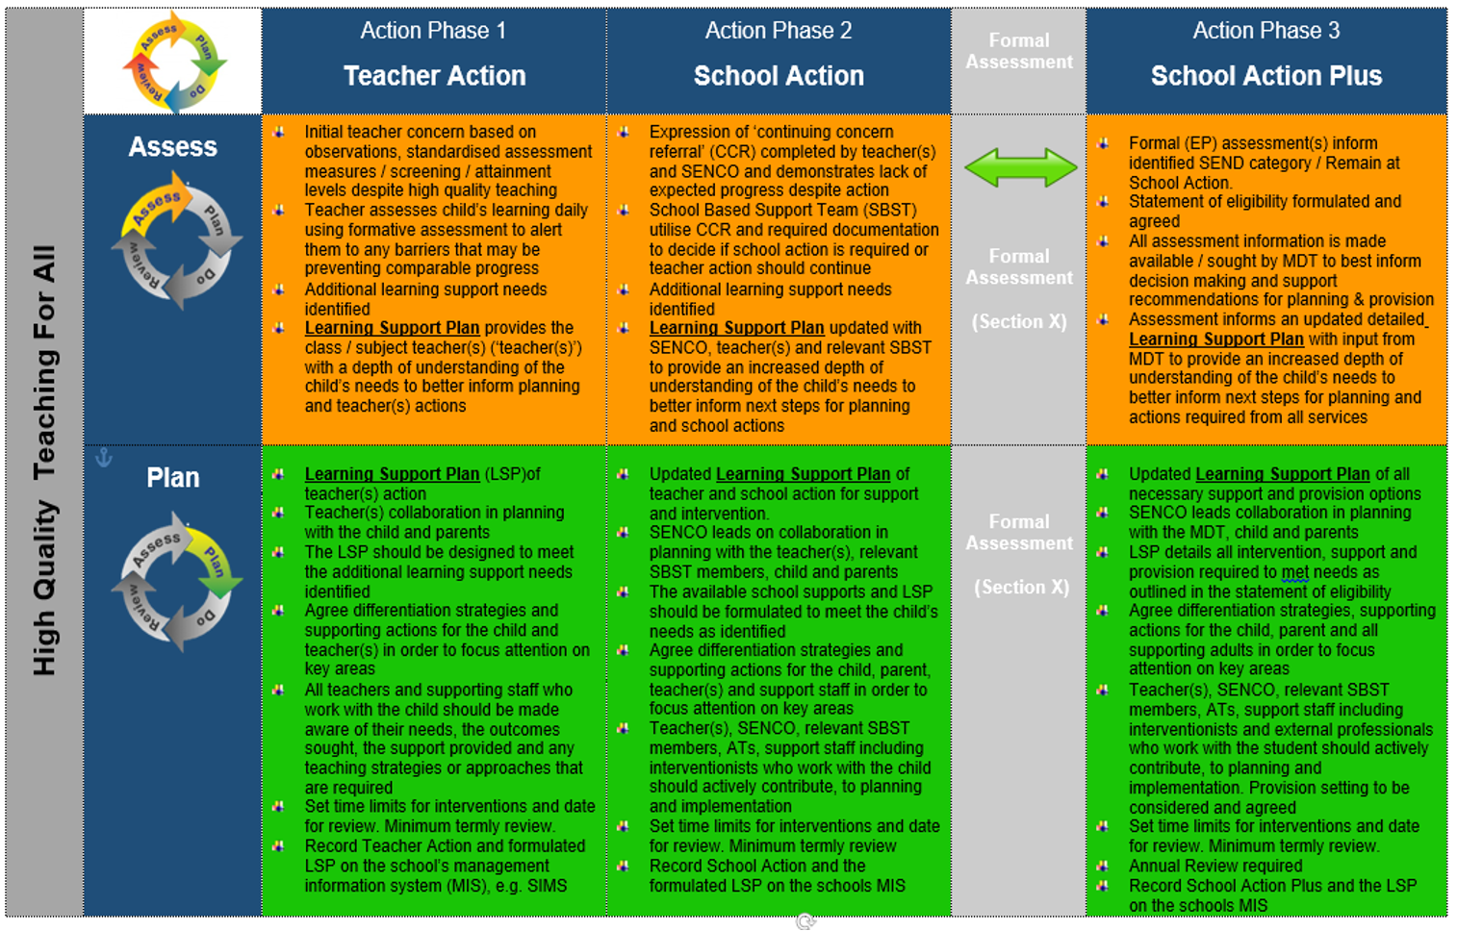
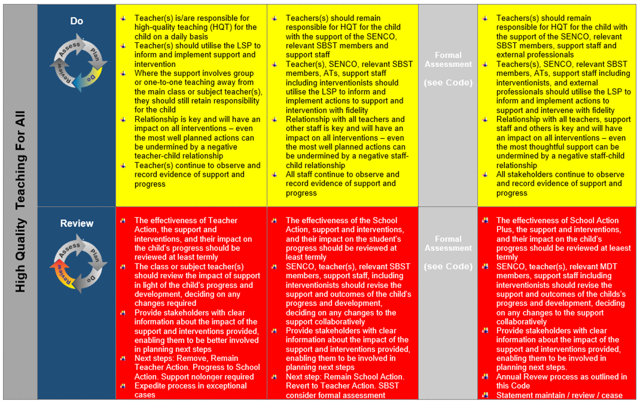

Statement of Eligibility
Children at Action Phase 3: School Action Plus, who have been formally assessed and identified with SEND are required by law to have those needs and the provision to be made in relation to them set out by CF School’s responsible authority in a statement of eligibility.
Annual Review: All children with a statement of eligibility, at Action Phase 3: School Action Plus, are required to have an Annual Review in line with Ministry of Education’s policy and strategy.
CF School is committed to the processes, expectations and responsibilities relating to the three phases of action outlined in the Code of Practice and all legal requirements as set out in both the Education Act, 2016 and the Education Regulations, 2017.
All students with ALSN, including SEND require a Learning Support Plan (LSP) across all 3 phases of action.

LSPs are be ‘SMARTER’:
· Specific, so that it is clear what the child should be working towards.
· Measurable, so that it is clear when the target has been achieved.
· Achievable for the individual student.
· Relevant, to the student’s needs and circumstances.
· Time-bound, so that the targets are to be achieved and reviewed termly at a minimum.
· Evaluated and changed if they are not working.
· Reviewed formally and shared with all the co-production team and success celebrated.

A LSP is a working document and should be reviewed termly at a minimum, through meetings and communication between the teacher/SENCO and the parents/guardians. It exists to help the student make steady and significant progress through additional support. This is to ensure that the LSP continues to address and meet the child’s needs. Parental/guardian input is important, as is the student’s views, if they are able to convey their thoughts, on the progress made and the effectiveness of the LSP. The teacher/SENCO will discuss the targets and whether they need to be refined/updated or have been achieved. New targets may also be set to be achieved by the next review date.

(7) Arrangements for ALSN/SEND

Curriculum Access:

Arrangements will be in place for providing all individuals with support and full access to a broad and balanced curriculum. CF School maintains very small class sizes of 5- 12 students to ensure all students receive individual attention and tailored learning. Differentiation is embedded within the curriculum to ensure all students can access all subjects at all times. CF School SENCO organizes 1:1 lessons for students who require additional individual support. LSPS are written with specific targets made with core subject teachers, to ensure that each student can progress and achieve. All students have access to our broad and robust curriculum and individual lessons are organized on a rotation so that no one subject is affected.
Ensuring Effective Inclusion:
All pupils, whether they have additional learning support needs or not, should be ‘included’ in the full life of the school. We actively seek to identify and remove the barriers to learning and participation that can hinder or exclude a child with additional learning support needs, including SEND. We ensure that children are included in a positive and proactive way. They should also approach inclusion as part of their overall improvement strategy. Inclusion in our school is about engendering a sense of community, belonging and meaningful participation, and encouraging collaboration to best support children with additional learning support needs, including SEND.
We aim to achieve inclusion by having:
- an inclusive ethos;
- a broad and balanced curriculum for all children;
- systems for early identification of barriers to learning and participation; and
- high expectations and suitable targets for all children.

(8) Training
All staff at CF School will have ongoing access to a range of training opportunities utilizing outside agencies and providers delivering training on a variety of topics related to ALSN / SEND. Some of these form part of the school’s training programme and others are open to staff through the Ministry of Education and Department of Education Services training opportunities.
Due to the small size of CF School, we recognise that working in collaboration with fellow subject specialists is beneficial to both staff development and student progress. As such, we have partnered with a number of consultant specialists who work with individual teachers to ensure consistency of high standards. To support the professional development of our school SENCo as well as the staff as a whole, a SEND consultant has been employed by the school. Our SEND consultant advises on policy, process and documenation. CF School has forged links between all supporting agencies which our students access. These professionals provide training and support for staff members on an ongoing basis to ensure a cohesive approach to each child’s support.
Our staff have the opportunity to attend specific training days, some of which relate to students with ALSN / SEND. Staff may also attend courses leading to specialist qualifications which enable more effective and achieve the best outcomes.
Within the school, expertise is also shared through discussions at staff meetings where information regarding ALSN / SEND is also exchanged.

(9) Complaints Procedure
If parents/guardians want to make a complaint with regard to any aspect of the identification, assessment and provision, the complaint should be directed to the Head-Teacher and Director of the school. CF School has their own complaints policy to which we adhere to in dealing with all complaints. A copy of the complaints policy is available on request.
Additionally, as set out, complaints can be made to the Chief Officer or the Chief Officer’s designate in accordance with the Ministry of Education’s policy and guidelines.

